Developing Quality Software & Systems

Project Assessment:

User Manual

Test Log

Solutions

IvalueU App Report

March 2021

Mohammed Faiyaz Hussain

ST2015599

Document Revisions

|  |  |  |
| --- | --- | --- |
| Date | Version Number | Document Changes |
| 15/02/2021 | 0.1 | Initial Draft |
| 04/03/2021 | 0.2 | Final Draft |
|  |  |  |
|  |  |  |
|  |  |  |
|  |  |  |
|  |  |  |
|  |  |  |
|  |  |  |

Table of Contents

1 User Manual

Introduction 4

1.1 Scope and Purpose 4

1.2 Process Overview 4

2 [Process/WorkFlow 1] 5

2.1 [Sub-Process or Workflow Step 1] Example: Configure Connect to manage your work 6

2.1.1 [Procedures for Step 1] Example: To Log in to Connect: 6

2.1.2 [Procedures for Step 2]: 7

2.2 [Sub-Process or Workflow Step 2] Example: Asset Record Statuses 7

3 Test Log 12

4 Solutions 21

# USER GUIDE

# 1 Introduction

## Scope and Purpose

The product that is being mentioned and guided through is the IValueU app which purpose was to help Key Stage 5 students go through it by signing up making an account or login if they have one. They can also look through tutorial videos on activities either indoor or outdoor and add photos on to it. In addition, the app contains navigational button which direct the user to different sections of the app.

The purpose of this guide is to show how the app was made, what codes were used and how

it functions to help new or current users. The guide will cover the definition of each term in

every page, the steps of logging in and signing up and adding new photos.

## Process Overview

1. Home- This page is the main page of the app; it contains navigational buttons that will ask you to login or sign up and lead to you to different sections of the app.
2. Sign Up- In the sign-up page to create an account you will have to add in your personal details.
3. Login- If you already have a username and password or created one then you will be asked to put them in the login section.
4. Physical Wellbeing- On this page you will see tutorial videos either indoor or outdoor created by primary school students.
5. Emotional Wellbeing- On this page you will see tutorial videos either indoor or outdoor created by primary school students.
6. Indoor/Outdoor- Both pages will contain the tutorial videos for physical and emotional wellbeing.
7. Photo Diary- This page will contain lists of photos that has been added and saved on to the camera roll from the camera.
8. Add New Photo- This section will be lead from the photo diary page to give the user the option to add a new photo.
9. Camera- This directed from the ‘add photo’ section and helps the user take photos with it.
10. Camera Roll- This section is the library of the recent photos taken by the user.
11. More- This page is an extra section that contains navigational buttons that lead you to the organizations b v and bibliography sections.
12. Organizations- This section is directed form the ‘More’ page.
13. Bibliography- This section is directed form the ‘More’ page.

# 2 [Process/WorkFlow 1]

**Register**

If the user wants the option to sing up on the app, then they will have to go through a few steps in order to access the app.

**Step1:** In order to create yourself an account on the app, you must click on the sign-up button on the Home page.

**Step 2:** The button will then redirect the user to the sign-up page where you must add and fill in the required boxes.

**Step 3:** Create a username.

**Step 4:** Input your primary email address that you generally use.

**Step 5:** Input your first name.

**Step 6:** Input your surname (family name).

**Step 7:** Input your Date of Birth.

**Step 8:** Create a password for your account.

**Step 9:** Click the submit button

**Step 10:** You have successfully created an account!

After you have inputted and entered the correct fields, the app will then direct you to the log in page where you, the user, will then be able to enter your details such as, your username and password which will then sign you into the app. However, if you incorrectly inputted the wrong details a small message will come up and notify you that you did something wrong. For example, please retype the correct username.

**Watching a Video**

**Step 1:** After you have successfully logged into the app, you will find five navigational button at the bottom of the screen, to watch the video tutorials of physical and emotional wellbeing, click either the indoor or outdoor button.

**Step 2:** After clicking the buttons, you will then be navigated to page that contains the button that will take to the physical or emotional wellbeing tutorial videos.

**Step 3:** After clicking either button, you will then be proceeded to a video selection page which you will be given an option to choose which video you would like to watch.

**Step 4:** If you proceed further after choosing a video in the selection, then you can either choose videos made by primary school students or physical indoor and outdoor videos made by people who are not students.

**Step 5:** When you have decided which video, you want to watch; you will then be redirected from the app to YouTube to play the video.

**Photo Diary**

**Step 1:** To access this part of the app, you will have to simply click the ‘Photo Diary’ navigational button located in the bottom section of the app.

**Step 2:** From then on you will be directed towards the ‘Photo Diary’ screen where you will access all the photos that you have saved however, if you want to add more photos then you will have to simply press the ‘Add’ button located at the top of the screen.

**Step 3:** After you have pressed the button you will be shown a screen with the option to give the photo a ‘Title’ and ‘Description’ and then can save it. Also, there is an option to use the camera as well.

**Step 4:** Once you have saved the photo it will be automatically be sent to your camera roll or library.

## sub-Process Screenshots of app

### To Log in to Connect:

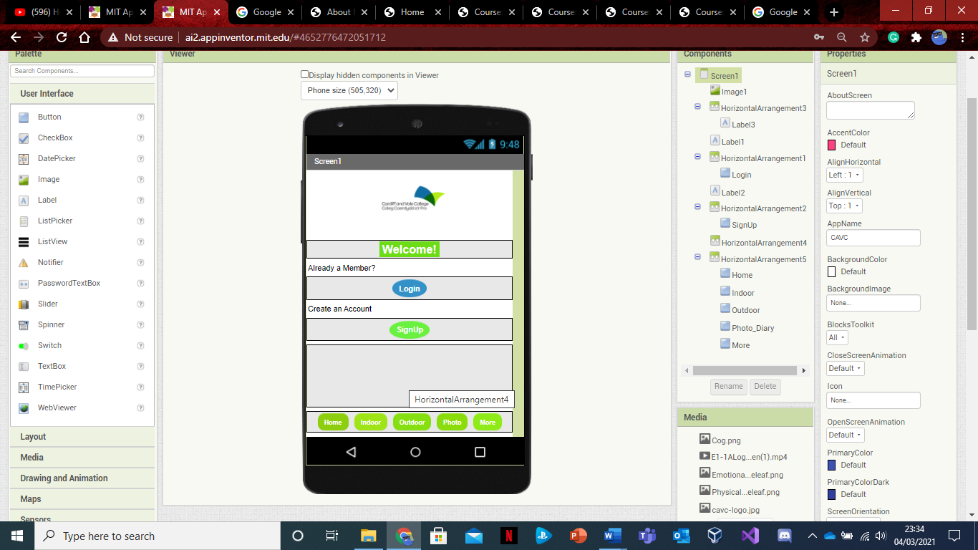**Register**

If the user wants the option to sing up on the app, then they will have to go through a few steps in order to access the app.

**Step1:** In order to create yourself an account on the app, you must click on the sign-up button on the Home page.

**Step 2:** The button will then redirect the user to the sign-up page where you must add and fill in the required boxes.

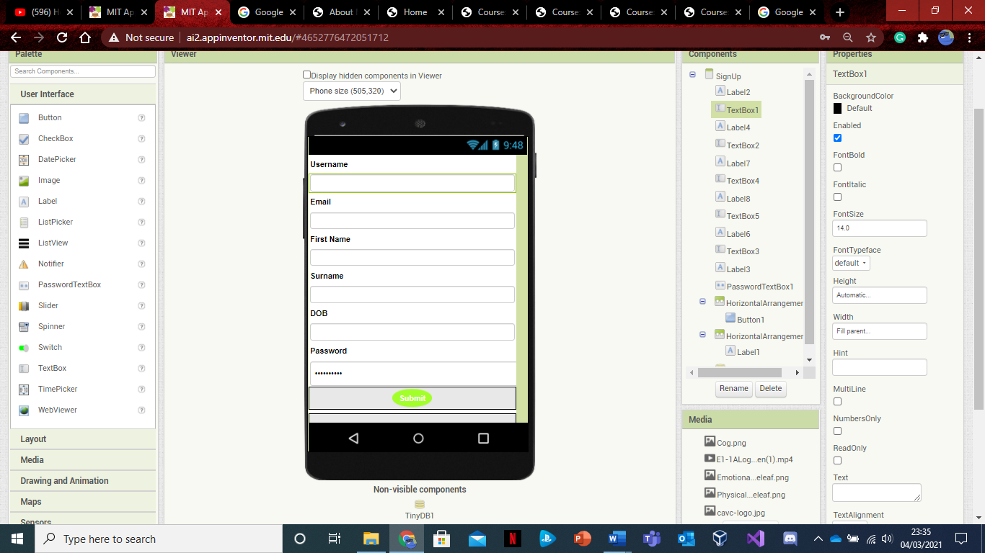

**Step 3:** Create a username.

**Step 4:** Input your primary email address that you generally use.

**Step 5:** Input your first name.

**Step 6:** Input your surname (family name).

**Step 7:** Input your Date of Birth.

**Step 8:** Create a password for your account.

**Step 9:** Click the submit button

**Step 10:** You have successfully created an account!



### Saving a Photo

**Photo Diary**

**Step 1:** To access this part of the app, you will have to simply click the ‘Photo Diary’ navigational button located in the bottom section of the app.

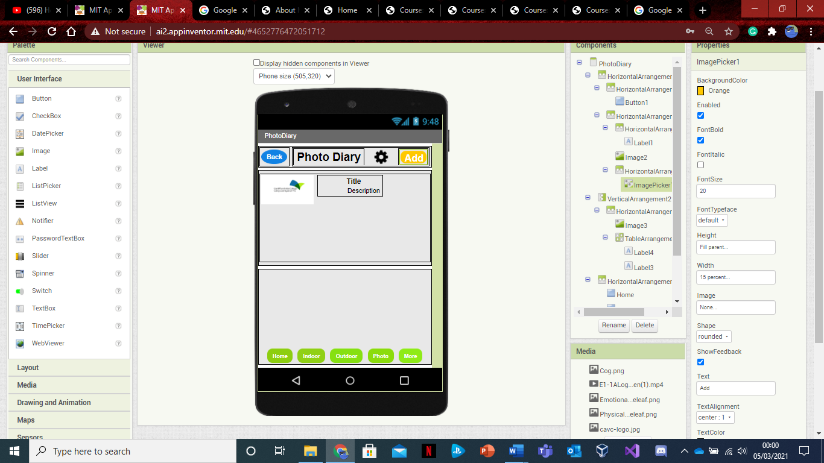**Step 2:** From then on you will be directed towards the ‘Photo Diary’ screen where you will access all the photos that you have saved however, if you want to add more photos then you will have to simply press the ‘Add’ button located at the top of the screen.

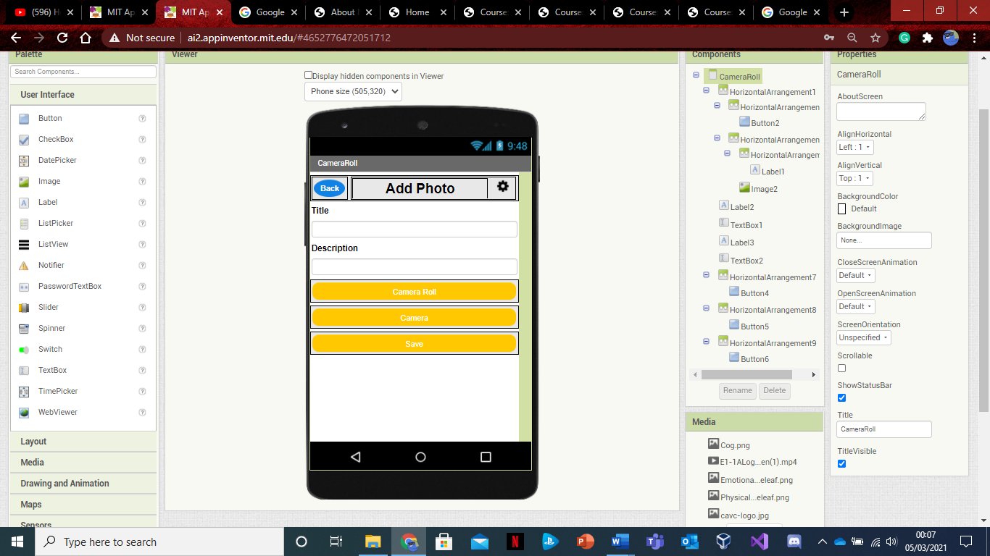

**Step 3:** After you have pressed the button you will be shown a screen with the option to give the photo a ‘Title’ and ‘Description’ and then can save it. Also, there is an option to use the camera as well.

**Step 4:** Once you have saved the photo it will be automatically be sent to your camera roll or library.

## Asset Record Statuses

Login

|  |  |
| --- | --- |
| Indicator | Definition |
| **Username** | This is where you enter and input your username to log in. |
| **Password** | This is where you input your password in order to log in. |

Register

|  |  |
| --- | --- |
| Indicator | Definition |
| **Username** | This is where you create your username for your account. |
| **Email** | This where you enter the primary email you generally use. |
| **First Name** | This is where you enter your first name or given name. |
| **Surname** | This is where you enter your surname or family name. |
| **Date of Birth (DOB)** | This is where you enter your date of birth i.e. the day, month, and year you were born. |
| **Password** | This is where you enter the password that you have created. |

Photo Diary

|  |  |
| --- | --- |
| Indicator | Definition |
| **Title** | This the name describing the image you taken and saved. |
| **Description** | This the text that will be describing what your image is about. |
| **Image** | This shows the image that you have taken. |

# Test Log

**Test Item:**  *User selects Physical Wellbeing video*

**Scope:** *Test the various selections of videos*

**Action: click on options**

**Test Notes and Preconditions:**

*User has logged into the system*

*User has chosen either indoor or outdoor videos*

**Verification Steps:** *Verification of the ability to select through the system, menus are linked, URLs are valid*

**Scenario 1:** *P1*

| **Test ID#** | **Action** | **Input Value** | **Expected Results** | **Actual Results** | **P/F** | **Automated** |
| --- | --- | --- | --- | --- | --- | --- |
| 1-1-1 | The user opens the physical wellbeing menu | Click | Menu displayed | Menu displayed | P | Y |
| 1-1-2 | User selects video from menu | Click | Menu displayed | Menu displayed | P | Y |
| 1-1-3 | User plays video | Click | Video Uploaded | Video Uploaded | P | Y |
| 1-1-4 | Video Plays from YouTube | Click | P1 video plays | P1 video plays | P | Y |

**Scope:** *Test the various selections of videos*

**Scenario 2:** *P2*

| **Test ID#** | **Action** | **Input Value** | **Expected Results** | **Actual Results** | **P/F** | **Automated** |
| --- | --- | --- | --- | --- | --- | --- |
| 1-2-1 | User selects video from menu | Click | Menu displayed | Menu displayed | P | Y |
| 1-2-2 | User plays video | Click | Video Uploaded | Video Uploaded | P | Y |
| 1-2-3 | Video Plays from YouTube | Click | P2 video plays | P2 video plays | P | Y |

**Scope:** *Test the various selections of videos*

**Scenario 3:** *P3*

| **Test ID#** | **Action** | **Input Value** | **Expected Results** | **Actual Results** | **P/F** | **Automated** |
| --- | --- | --- | --- | --- | --- | --- |
| 1-3-1 | User selects video from menu | Click | Menu displayed | Menu displayed | P | Y |
| 1-3-2 | User plays video | Click | Video Uploaded | Video Uploaded | P | Y |
| 1-3-3 | Video Plays from YouTube | Click | P3 video plays | P3 video plays | P | Y |

**Scope:** *Test the various selections of videos*

**Scenario 4:** *P4*

| **Test ID#** | **Action** | **Input Value** | **Expected Results** | **Actual Results** | **P/F** | **Automated** |
| --- | --- | --- | --- | --- | --- | --- |
| 1-4-1 | User selects video from menu | Click | Menu displayed | Menu displayed | P | Y |
| 1-4-2 | User plays video | Click | Video Uploaded | Video Uploaded | P | Y |
| 1-4-3 | Video Plays from YouTube | Click | P4 video plays | P4 video plays | P | Y |

**Test Item:**  *User selects Emotional Wellbeing video*

**Scope:** *Test the various selections of videos*

**Action: click on options**

**Test Notes and Preconditions:**

*User has logged into the system*

*User has chosen either indoor or outdoor videos*

**Verification Steps:** *Verification of the ability to select through the system, menus are linked, URLs are valid*

**Scenario 1:** *E1-1*

| **Test ID#** | **Action** | **Input Value** | **Expected Results** | **Actual Results** | **P/F** | **Automated** |
| --- | --- | --- | --- | --- | --- | --- |
| 2-1-1 | The user opens the physical wellbeing menu | Click | Menu displayed | Menu displayed | P | Y |
| 2-1-2 | User selects video from menu | Click | Menu displayed | Menu displayed | P | Y |
| 2-1-3 | User plays video | Click | Video Uploaded | Video Uploaded | P | Y |
| 2-1-4 | Video Plays from YouTube | Click | E1-1 video plays | E1-1 video plays | P | Y |

**Scope:** *Test the various selections of videos*

**Scenario 2:** *E1-2*

| **Test ID#** | **Action** | **Input Value** | **Expected Results** | **Actual Results** | **P/F** | **Automated** |
| --- | --- | --- | --- | --- | --- | --- |
| 2-2-1 | User selects video from menu | Click | Menu displayed | Menu displayed | P | Y |
| 2-2-2 | User plays video | Click | Video Uploaded | Video Uploaded | P | Y |
| 2-2-3 | Video Plays from YouTube | Click | E1-2 video plays | E1-2 video plays | P | Y |

**Scope:** *Test the various selections of videos*

**Scenario 3:** *E1-3*

| **Test ID#** | **Action** | **Input Value** | **Expected Results** | **Actual Results** | **P/F** | **Automated** |
| --- | --- | --- | --- | --- | --- | --- |
| 2-3-1 | User selects video from menu | Click | Menu displayed | Menu displayed | P | Y |
| 2-3-2 | User plays video | Click | Video Uploaded | Video Uploaded | P | Y |
| 2-3-3 | Video Plays from YouTube | Click | E1-3 video plays | E1-3 video plays | P | Y |

**Scope:** *Test the various selections of videos*

**Scenario 4:** *E1-4*

| **Test ID#** | **Action** | **Input Value** | **Expected Results** | **Actual Results** | **P/F** | **Automated** |
| --- | --- | --- | --- | --- | --- | --- |
| 2-4-1 | User selects video from menu | Click | Menu displayed | Menu displayed | P | Y |
| 2-4-2 | User plays video | Click | Video Uploaded | Video Uploaded | P | Y |
| 2-4-3 | Video Plays from YouTube | Click | E1-4 video plays | E1-4 video plays | P | Y |

**Scope:** *Test the various selections of videos*

**Scenario 6:** *E2-1*

| **Test ID#** | **Action** | **Input Value** | **Expected Results** | **Actual Results** | **P/F** | **Automated** |
| --- | --- | --- | --- | --- | --- | --- |
| 2-5-1 | User selects video from menu | Click | Menu displayed | Menu displayed | P | Y |
| 2-5-2 | User plays video | Click | Video Uploaded | Video Uploaded | P | Y |
| 2-5-3 | Video Plays from YouTube | Click | E2-1 video plays | E2-1 video plays | P | Y |

**Scope:** *Test the various selections of videos*

**Scenario 7:** *E2-2*

| **Test ID#** | **Action** | **Input Value** | **Expected Results** | **Actual Results** | **P/F** | **Automated** |
| --- | --- | --- | --- | --- | --- | --- |
| 2-6-1 | User selects video from menu | Click | Menu displayed | Menu displayed | P | Y |
| 2-6-2 | User plays video | Click | Video Uploaded | Video Uploaded | P | Y |
| 2-6-3 | Video Plays from YouTube | Click | E2-2 video plays | E2-2 video plays | P | Y |

**Scope:** *Test the various selections of videos*

**Scenario 8:** *E2-3*

| **Test ID#** | **Action** | **Input Value** | **Expected Results** | **Actual Results** | **P/F** | **Automated** |
| --- | --- | --- | --- | --- | --- | --- |
| 2-7-1 | User selects video from menu | Click | Menu displayed | Menu displayed | P | Y |
| 2-7-2 | User plays video | Click | Video Uploaded | Video Uploaded | P | Y |
| 2-7-3 | Video Plays from YouTube | Click | E2-3 video plays | E2-3 video plays | P | Y |

**Scope:** *Test the various selections of videos*

**Scenario 9:** *E2-4*

| **Test ID#** | **Action** | **Input Value** | **Expected Results** | **Actual Results** | **P/F** | **Automated** |
| --- | --- | --- | --- | --- | --- | --- |
| 2-8-1 | User selects video from menu | Click | Menu displayed | Menu displayed | P | Y |
| 2-8-2 | User plays video | Click | Video Uploaded | Video Uploaded | P | Y |
| 2-8-3 | Video Plays from YouTube | Click | E2-4 video plays | E2-4 video plays | P | Y |

**Scope:** *Test the various selections of videos*

**Scenario 10:** *E3-1*

| **Test ID#** | **Action** | **Input Value** | **Expected Results** | **Actual Results** | **P/F** | **Automated** |
| --- | --- | --- | --- | --- | --- | --- |
| 2-9-1 | User selects video from menu | Click | Menu displayed | Menu displayed | P | Y |
| 2-9-2 | User plays video | Click | Video Uploaded | Video Uploaded | P | Y |
| 2-9-3 | Video Plays from YouTube | Click | E3-1 video plays | E3-1 video plays | P | Y |

**Scope:** *Test the various selections of videos*

**Scenario 11:** *E3-2*

| **Test ID#** | **Action** | **Input Value** | **Expected Results** | **Actual Results** | **P/F** | **Automated** |
| --- | --- | --- | --- | --- | --- | --- |
| 3-0-1 | User selects video from menu | Click | Menu displayed | Menu displayed | P | Y |
| 3-0-2 | User plays video | Click | Video Uploaded | Video Uploaded | P | Y |
| 3-0-3 | Video Plays from YouTube | Click | E3-2 video plays | E3-2 video plays | P | Y |

**Scope:** *Test the various selections of videos*

**Scenario 12:** *E3-3*

| **Test ID#** | **Action** | **Input Value** | **Expected Results** | **Actual Results** | **P/F** | **Automated** |
| --- | --- | --- | --- | --- | --- | --- |
| 3-1-1 | User selects video from menu | Click | Menu displayed | Menu displayed | P | Y |
| 3-1-2 | User plays video | Click | Video Uploaded | Video Uploaded | P | Y |
| 3-1-3 | Video Plays from YouTube | Click | E3-3 video plays | E3-3 video plays | P | Y |

**Scope:** *Test the various selections of videos*

**Scenario 13:** *E3-4*

| **Test ID#** | **Action** | **Input Value** | **Expected Results** | **Actual Results** | **P/F** | **Automated** |
| --- | --- | --- | --- | --- | --- | --- |
| 3-2-1 | User selects video from menu | Click | Menu displayed | Menu displayed | P | Y |
| 3-2-2 | User plays video | Click | Video Uploaded | Video Uploaded | P | Y |
| 3-2-3 | Video Plays from YouTube | Click | E3-4 video plays | E3-4 video plays | P | Y |

**Scope:** *Test the various selections of videos*

**Scenario 14:** *E3-5*

| **Test ID#** | **Action** | **Input Value** | **Expected Results** | **Actual Results** | **P/F** | **Automated** |
| --- | --- | --- | --- | --- | --- | --- |
| 3-3-1 | User selects video from menu | Click | Menu displayed | Menu displayed | P | Y |
| 3-3-2 | User plays video | Click | Video Uploaded | Video Uploaded | P | Y |
| 3-3-3 | Video Plays from YouTube | Click | E3-5 video plays | E3-5 video plays | P | Y |

**Scope:** *Test the various selections of videos*

**Scenario 15:** *E4-1*

| **Test ID#** | **Action** | **Input Value** | **Expected Results** | **Actual Results** | **P/F** | **Automated** |
| --- | --- | --- | --- | --- | --- | --- |
| 3-4-1 | User selects video from menu | Click | Menu displayed | Menu displayed | P | Y |
| 3-4-2 | User plays video | Click | Video Uploaded | Video Uploaded | P | Y |
| 3-4-3 | Video Plays from YouTube | Click | E4-1 video plays | E4-1 video plays | P | Y |

**Scope:** *Test the various selections of videos*

**Scenario 16:** *E4-2*

| **Test ID#** | **Action** | **Input Value** | **Expected Results** | **Actual Results** | **P/F** | **Automated** |
| --- | --- | --- | --- | --- | --- | --- |
| 3-5-1 | User selects video from menu | Click | Menu displayed | Menu displayed | P | Y |
| 3-5-2 | User plays video | Click | Video Uploaded | Video Uploaded | P | Y |
| 3-5-3 | Video Plays from YouTube | Click | E4-2 video plays | E4-2 video plays | P | Y |

**Scope:** *Test the various selections of videos*

**Scenario 17:** *E4-3*

| **Test ID#** | **Action** | **Input Value** | **Expected Results** | **Actual Results** | **P/F** | **Automated** |
| --- | --- | --- | --- | --- | --- | --- |
| 3-6-1 | User selects video from menu | Click | Menu displayed | Menu displayed | P | Y |
| 3-6-2 | User plays video | Click | Video Uploaded | Video Uploaded | P | Y |
| 3-6-3 | Video Plays from YouTube | Click | E4-3 video plays | E4-3 video plays | P | Y |

**Scope:** *Test the various selections of videos*

**Scenario 18:** *E4-4*

| **Test ID#** | **Action** | **Input Value** | **Expected Results** | **Actual Results** | **P/F** | **Automated** |
| --- | --- | --- | --- | --- | --- | --- |
| 3-7-1 | User selects video from menu | Click | Menu displayed | Menu displayed | P | Y |
| 3-7-2 | User plays video | Click | Video Uploaded | Video Uploaded | P | Y |
| 3-7-3 | Video Plays from YouTube | Click | E4-4 video plays | E4-4 video plays | P | Y |

**Scope:** *Test the various selections of videos*

**Scenario 19:** *E4-5*

| **Test ID#** | **Action** | **Input Value** | **Expected Results** | **Actual Results** | **P/F** | **Automated** |
| --- | --- | --- | --- | --- | --- | --- |
| 3-8-1 | User selects video from menu | Click | Menu displayed | Menu displayed | P | Y |
| 3-8-2 | User plays video | Click | Video Uploaded | Video Uploaded | P | Y |
| 3-8-3 | Video Plays from YouTube | Click | E4-5 video plays | E4-5 video plays | P | Y |

**Scope:** *Test the various selections of videos*

**Scenario 20:** *Meditation Video*

| **Test ID#** | **Action** | **Input Value** | **Expected Results** | **Actual Results** | **P/F** | **Automated** |
| --- | --- | --- | --- | --- | --- | --- |
| 3-9-1 | User selects video from menu | Click | Menu displayed | Menu displayed | P | Y |
| 3-9-2 | User plays video | Click | Video Uploaded | Video Uploaded | P | Y |
| 3-9-3 | Video Plays from YouTube | Click | Meditation video plays | Meditation video plays | P | Y |

**Test Item:**  *User selects Photo Diary*

**Scope:** *Test the addition of image to camera roll*

**Action: click on options**

**Test Notes and Preconditions:**

*User can choose to add a photo into the camera roll*

**Verification Steps:** *Verification of the ability to select through the system, menus are linked, URLs are valid*

**Scenario 21:** *N/A*

| **Test ID#** | **Action** | **Input Value** | **Expected Results** | **Actual Results** | **P/F** | **Automated** |
| --- | --- | --- | --- | --- | --- | --- |
| 4-0-1 | The user opens the photo diary page | Click | Page displayed | Page displayed | P | Y |
| 4-0-2 | User selects add photo | Click | screen displayed | screen displayed | P | Y |
| 4-0-3 | User saves image on to camera roll | Click | Image saved | Image saved | P | Y |
| 4-0-4 | User Views camera roll | Click | Page displayed | Page displayed | P | Y |

**Test Item:**  *User selects More Screen*

**Scope:** *Test the navigation to another screen*

**Action: click on options**

**Test Notes and Preconditions:**

*User can choose to go to the bibliography and organisations page.*

**Verification Steps:** *Verification of the ability to select through the system, menus are linked, URLs are valid*

**Scenario 22:** *N/A*

| **Test ID#** | **Action** | **Input Value** | **Expected Results** | **Actual Results** | **P/F** | **Automated** |
| --- | --- | --- | --- | --- | --- | --- |
| 4-1-1 | The user opens the More Screen navigational button | Click | Page displayed | Page displayed | P | Y |
| 4-1-2 | User views More Screen | Click | More screen displayed | More screen displayed | P | Y |

# Bug log

|  |  |  |  |
| --- | --- | --- | --- |
| Bug ID | Test ID | Description of error/review/solution | Resolved |
| #001 | 1-1-1/  1-1-6 | It played video P4 instead of P3- Review URL pointing to P3 instead of P4.  Corrected URL as suggested | Y |

# Solutions

